Creating the

e-Learning Course Content Storyboard/Outline

Fill out the content storyboard below. Include all of the detail the learning developer will need: Sketches, text, images, instructions, etc. For help, see the examples below the blank template.

Lesson #: Performing Dotted Quarter 8th Notes
Page # | Page Title | Page Template Type | Media: | On-Screen Text | Notes to Developer
1 | Home page | -Full Screen Music Background  -Buttons for learning dotted quarter 8th notes per concept | Image | Header: DOTTED QUARTER 8th Notes  Button Text are…  - Listening to  - Identifying  - Composing  - Performing

Mockup/Sketch:

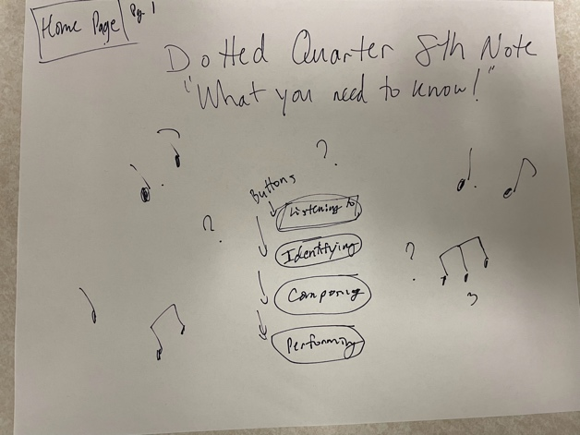
 |  |  |  | Button 1: “Listening to…” | Links to pg 2
 |  |  |  | Button 2: “Identifying…” | Links to pg 3
 |  |  |  | Button 3: “Composing…” | Links to pg 4
 |  |  |  | Button 4: “Performing…” | Links to pg 5
Page # | Page Title | Page Template Type | Media: | On-Screen Text | Notes to Developer
2 | Listening to DQ8 | Main Page BG Image  Video center screen | Video Link - https://www.youtube.com/watch?v=7jpTSez0SHY&t=258s at 4:18 | What do DQ8 note rhythms sound like?  Selection from Dvorak: Symphony No. 9 “From the New World”

Mockup/Sketch:

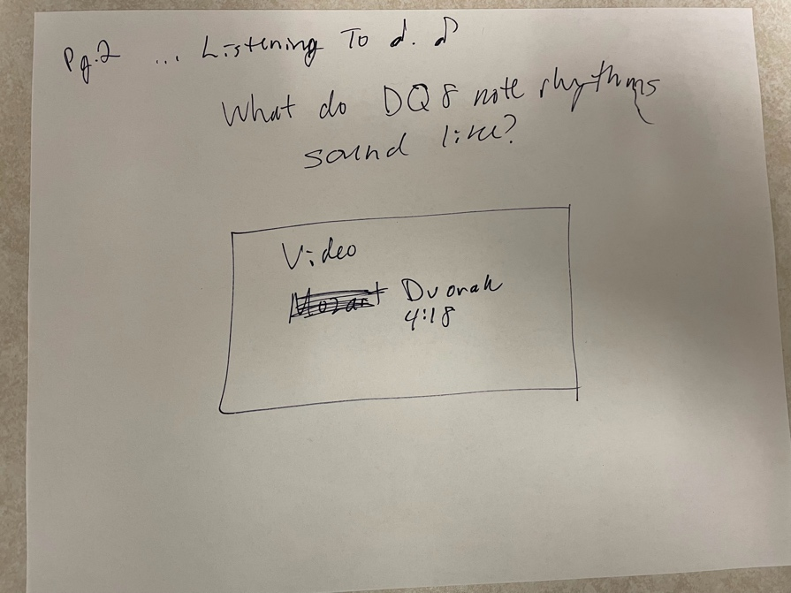
 |  |  |  | Button 1: “Home Page” | Pg. 1
 |  |  |  | Button 2: “Identify DQ8” | Pg. 3

Page # | Page Title | Page Template Type | Media: | On-Screen Text | Notes to Developer
Pg. 3 | Identifying Dotted quarter 8th notes | Main Page BG Image  Image center screen | Image – Link - https://www.makingmusicfun.net/pdf/sheet_music/new-world-symphony-piano-solo.pdf | Identifying Dotted Quarter 8th Notes  What do DQ8 notes look like?

Mockup/Sketch:

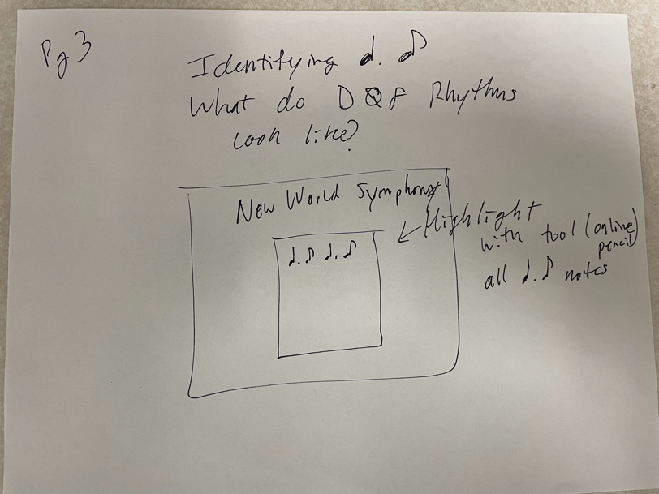
 |  |  |  | Button 1: “Home Page” | Pg. 1
 |  |  |  | Button 2: “Composing DQ8” | Pg. 4

Page # | Page Title | Page Template Type | Media: | On-Screen Text | Notes to Developer
Pg. 4 | Composing Dotted quarter 8th notes | Main Page BG Image  Music Staff Image center screen | Image – Link - https://i2.wp.com/printerfriend.ly/wp-content/uploads/2020/04/PRINTABLE_STAFF_PAPER1-scaled.jpg?ssl=1 | Composing Dotted Quarter 8th Notes  Can you compose DQ8 notes?

Mockup/Sketch:

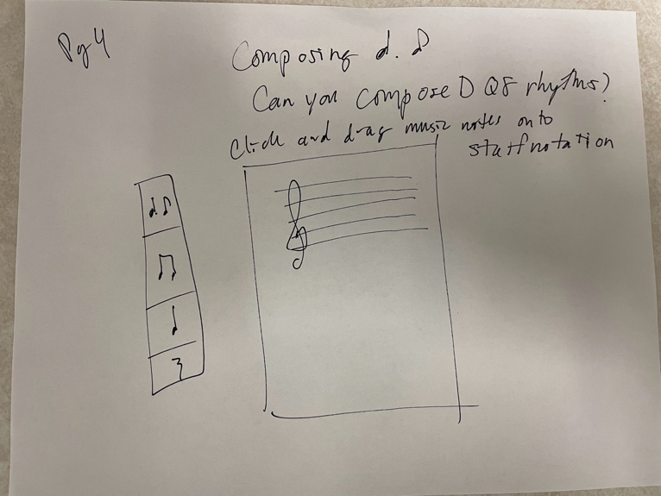
 |  |  |  | Button 1: “Home Page” | Pg. 1
 |  |  |  | Button 2: “Performing DQ8” | Pg. 5

Page # | Page Title | Page Template Type | Media: | On-Screen Text | Notes to Developer
Pg. 5 | Performing Dotted quarter 8th notes | Main Page BG Image  Recording software center screen | Embed Canva Recording Application? | Performing Dotted Quarter 8th Notes  Can you perform DQ8 notes?

Mockup/Sketch:

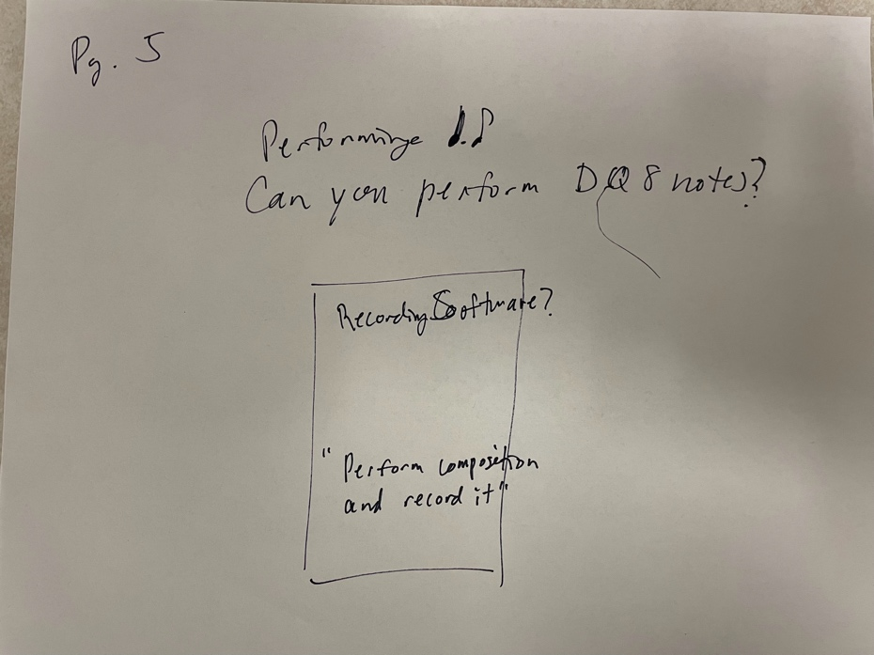
 |  |  |  | Button 1: “Home Page” | Pg. 1
 |  |  |  | Button 2: “Feedback” | Pg. 6

Page # | Page Title | Page Template Type | Media: | On-Screen Text | Notes to Developer
Pg. 6 | Feedback | Main Page BG Image  Open text box center screen | None | Do you now feel that you can properly perform DQ8 notes? Did this tutorial help? Why or Why Not?

Mockup/Sketch:

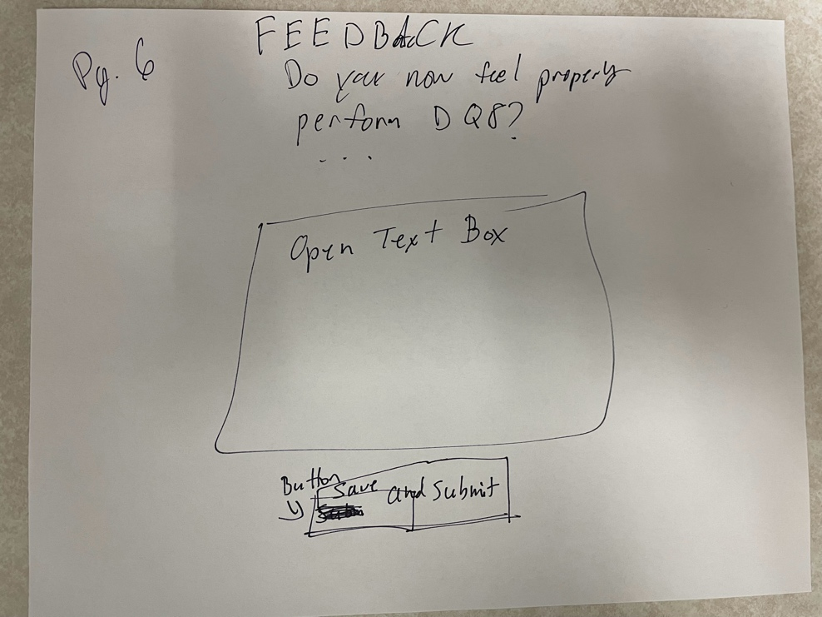
 |  |  |  | Button 1: “Save and Submit” | Pg. 1 (after being saved, send to page 1)

